Clustering depth in Snowflake represents the average number of overlapping micro-partitions for specified columns in a table. It provides a measure of how well the data is physically organized on disk with respect to those columns: lower clustering depth indicates better clustering and less overlap, which generally leads to more efficient query pruning and faster performance.
Purpose of clustering depth:
- It helps monitor table fragmentation as data is inserted/updated over time.
- It indicates whether the table would benefit from explicit clustering (using a clustering key).
- A lower clustering depth (closer to 1) means rows with similar values for the clustering key are grouped together in fewer partitions, making query scans more efficient. Higher depth means more overlap, which can hurt pruning and slow down queries.
Depth buckets (partition depth histogram):
- Snowflake provides a histogram to analyze clustering depth distribution across all micro-partitions.
- Buckets group micro-partitions by their overlap depth:
  - Buckets 0–16 are "fine-grained," covering overlap depths 0 through 16 exactly.
  - Beyond 16, bucket sizes double (32, 64, 128, etc.) to efficiently summarize rare high-overlap micro-partitions.
- The histogram shows, for each depth range (bucket), how many micro-partitions fall into that category. This visualization helps identify how many partitions have high overlap (possibly indicating a need for reclustering).
Overlapping of Micro partitions across different depth buckets
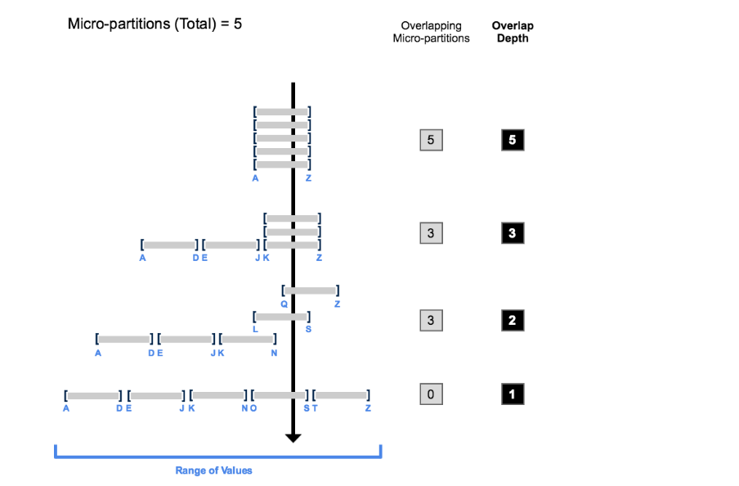

Micro partitions and Metadata
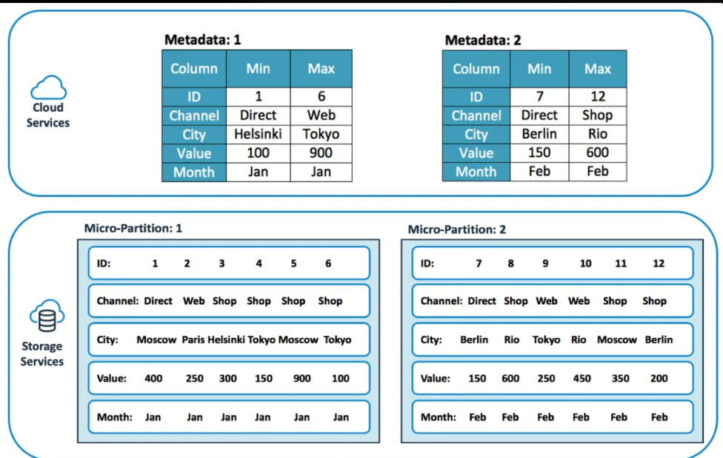
Key concepts:
- Micro-partition: The basic storage and pruning unit in Snowflake. Same column value in multiple partitions indicates overlap.
- Overlap depth: Number of micro-partitions containing the same value (or range of values) for the clustering column(s).
- Clustering key: Optional, user-defined column(s) for which clustering depth is monitored and can be improved via reclustering.
Summary:
- Clustering depth is critical for maintaining query performance in large tables.
- Depth buckets (histogram) provide insight into the distribution of overlap, helping decide when table reclustering may be beneficial.
If table queries are performing as needed, clustering depth is less important. But for large or heavily updated tables, monitoring and acting on clustering depth and bucket distributions is key for performance optimization.

